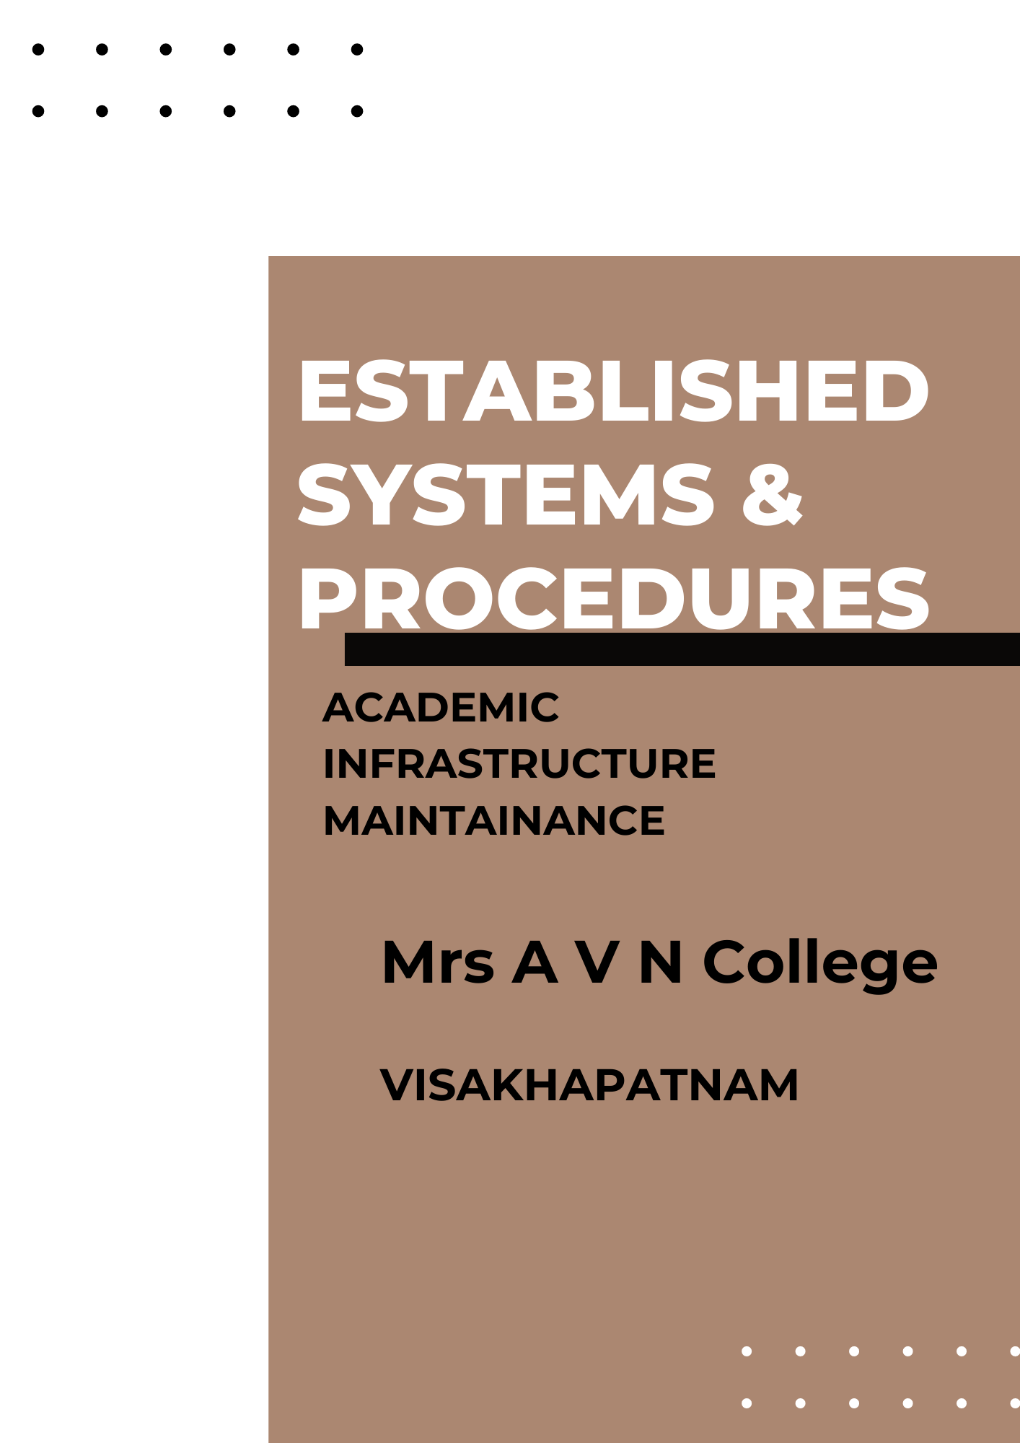

**Mrs A V N College**

**Visakhapatnam**

**Established systems and procedures**

**Maintaining and utilizing physical, academic and support facilities laboratory, library, sports complex, computers, classrooms etc.**

**Established Systems and Procedures**

The College has a well established system & procedure for maintenance and utilization of available supporting facilities. The Principal discusses with the Planning and Evaluation Committee and presents a report regarding physical, academic and support facilities in the Governing Body for approval. The Correspondant is empowered to deal with all matters pertaining to the acquisition, up-keeping and disposal of campus infrastructure. An annual audit and inventory of the facilities is undertaken for assessment and evaluation. Maintenance of Physical Facilities Maintenance of the physical facilities is done throughout the year and major repair works are carried out during summer vacation. Annual Maintenance Contract (AMC) is arranged for air-conditioners, generators, and other equipment. Fire extinguishers and First Aid Kits are maintained regularly, and refilling is done before their date of expiry. Cleaning and maintenance are done steadily through support staff. The security of the campus is taken care of by the Outsourced Security Guards.

**i) Maintenance of Academic and Support Facilities**

1. **CCTV cameras** have been installed to ensure safe keeping.
2. **Laboratory**

Inventory of all the equipment, instruments, glassware, specimens, computing devices etc. is done by the respective Departments annually. Fault Registers and Logbooks in the laboratories are regularly maintained.

For any kind of maintenance or repair, the laboratory staff-in-charge reports to the respective HoD who forwards it to the Principal and the Correspondent/Vice-chairman. The repair work is carried out by the concerned service person. The instruments and equipment are serviced by the suppliers from whom they are purchased. Separate maintenance register is kept with details of maintenance entries i.e., name of instrument, date, and description of maintenance. The sensitive laboratory equipment is housed in air-conditioned instrument rooms.

Laboratory is also used for conducting skill tests for HPCL Laboratory assistant recruitment and other tests.

1. **Library**

Library is partially computerized & it is equipped with OPAC. Pest control has been done in the library regularly to maintain books safe from crickets and termites. Ceasefire is kept in the library for any fire emergencies.

All books in the library are arranged according to their classification. The library support-staff help in maintaining the books and other infrastructure in the library. Damaged books are bound. The annual inventory is carried out during summer vacation.

1. **Computers**

A programmer and a faculty member are in charge of every computer lab. one hardware technician and one electrician take care of the maintenance and service of the computers and electrical connections. All Wi-Fi users are controlled through a firewall.

1. **Sports**

The playgrounds and courts are periodically maintained; cleaning and marking are undertaken regularly. The Department of Physical Education maintains stock registers, accession register, and stock issue register. Every year, essential new equipment is added.

1. **Hostels**

One hostel is provided for 100 boys. The hostel functions with one warde and and Hostel Student Council.

1. **Bank**

A branch of Indian Bank with ATM to facilitate online/offline transactions

1. **Canteen**

Canteen facility in the college premises for the staff and students It provides healthy and nutritious snacks and edible items at an affordable price.

1. **Classrooms**

They are regularly cleaned by outsourcing supporting staff. They are also used for the state and central government exams in the holidays.

**ii) Maintenance of Electricity & Physical facilities**

Electricity and physical facilities related maintenance done regularly as per requirements. College has various equipment like, Generator, 2 Xerox machines, a few printers, Cease fire equipment, CCTV cameras, Audio system, Digital Camera and Inverters etc. There is some fund/ expense that has been paid regularly or every year on these equipment to maintain all above facilities.

One technician is appointed for IT maintenance and another technician is for electrical maintenance. Administrative officer looks after the repair and maintenance of Infrastructure and physical facilities.